Module -Home

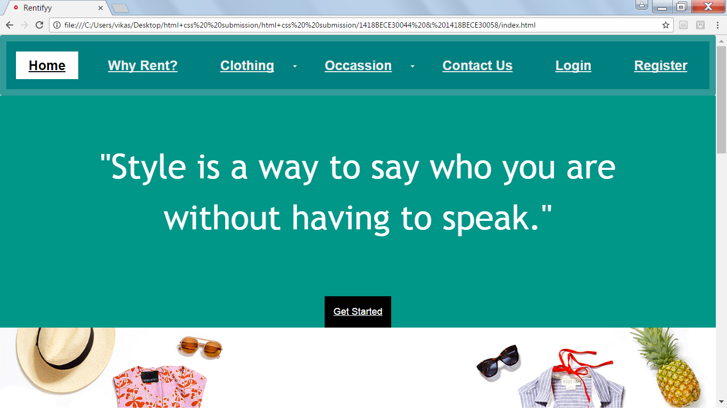

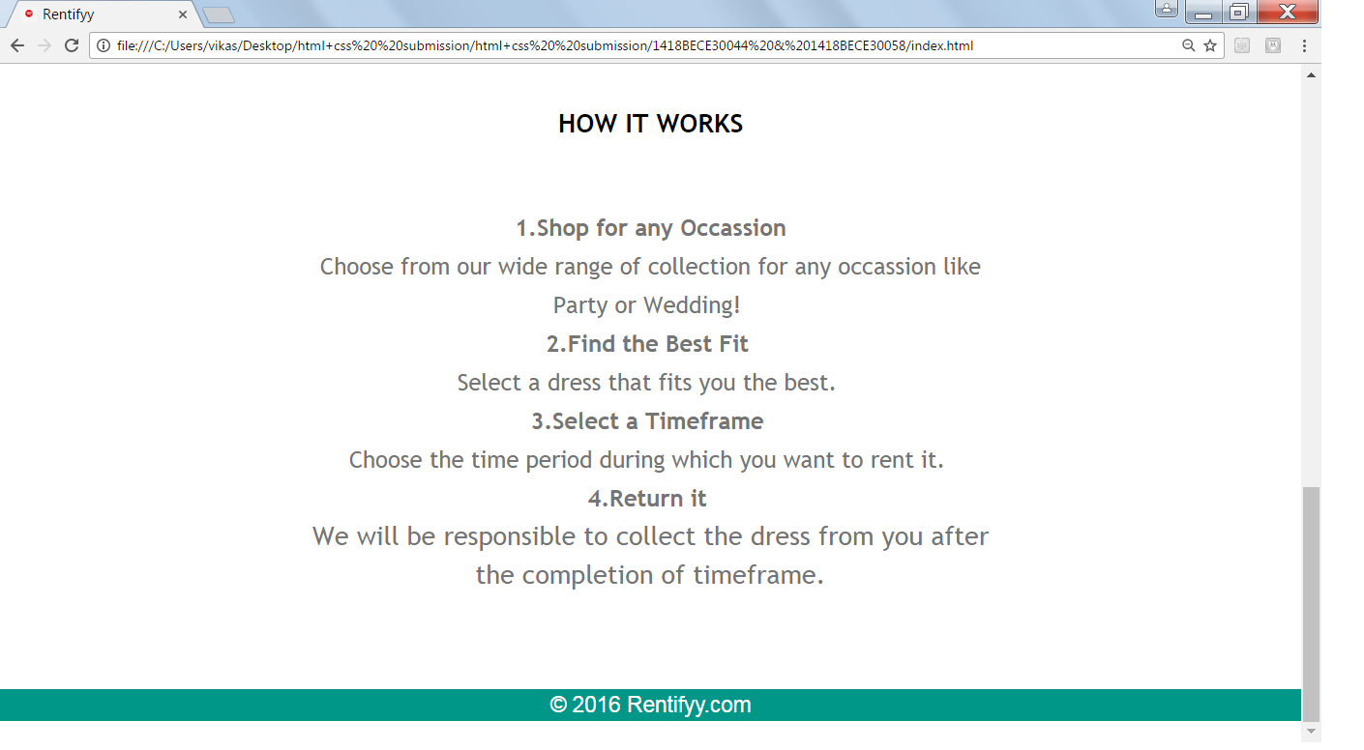

At first the user will be by default directed to Home page which has the Get Started option. It also contains a description of “How It Works”.

Module-Why Rent?

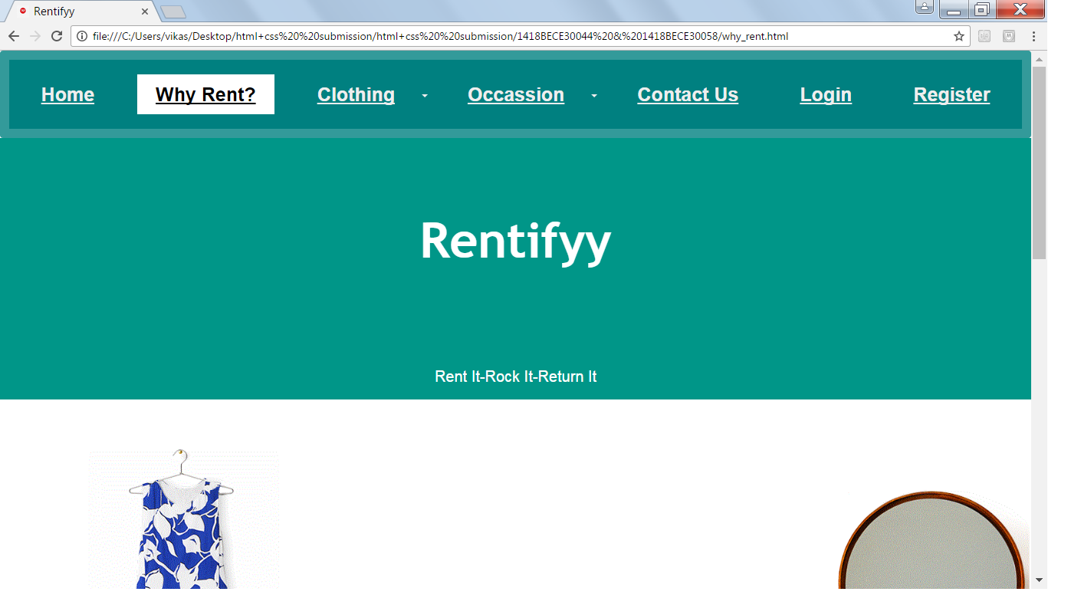

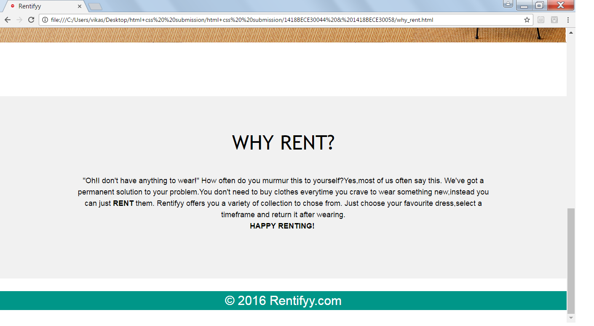

This page describes the problem and our attempt to provide a solution to it through Rentifyy.

Module-Clothing

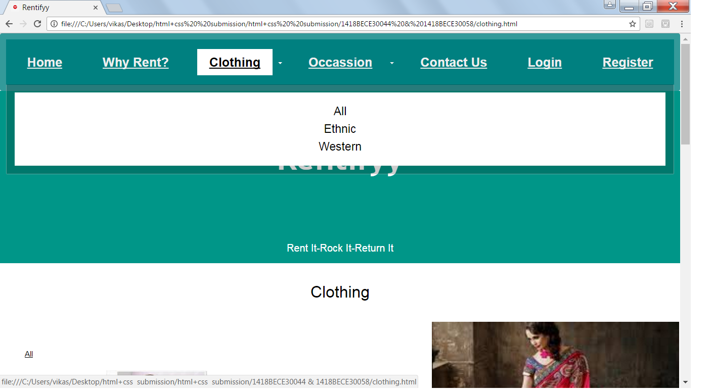

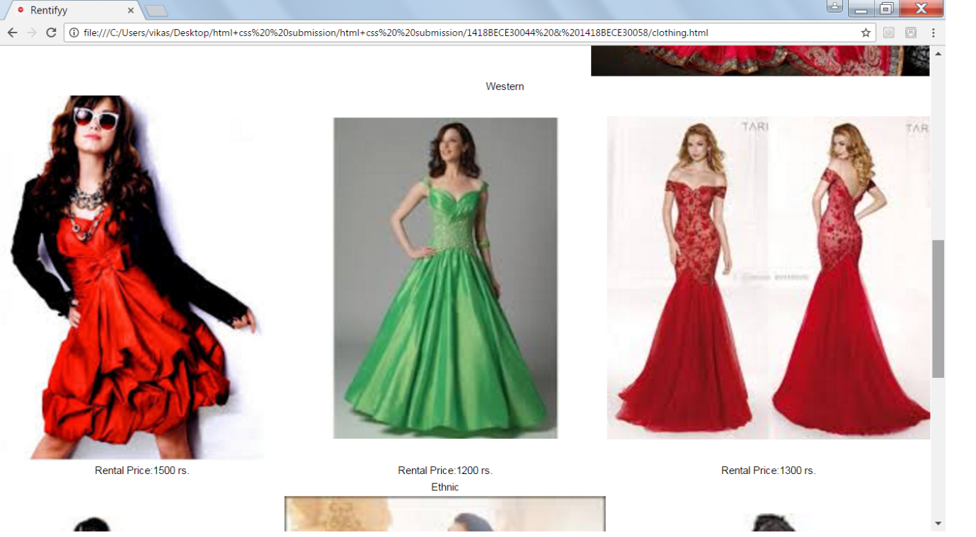

This category of Clothing gives user the option of selecting from Ethnic and Western clothes.

Module- Occasion

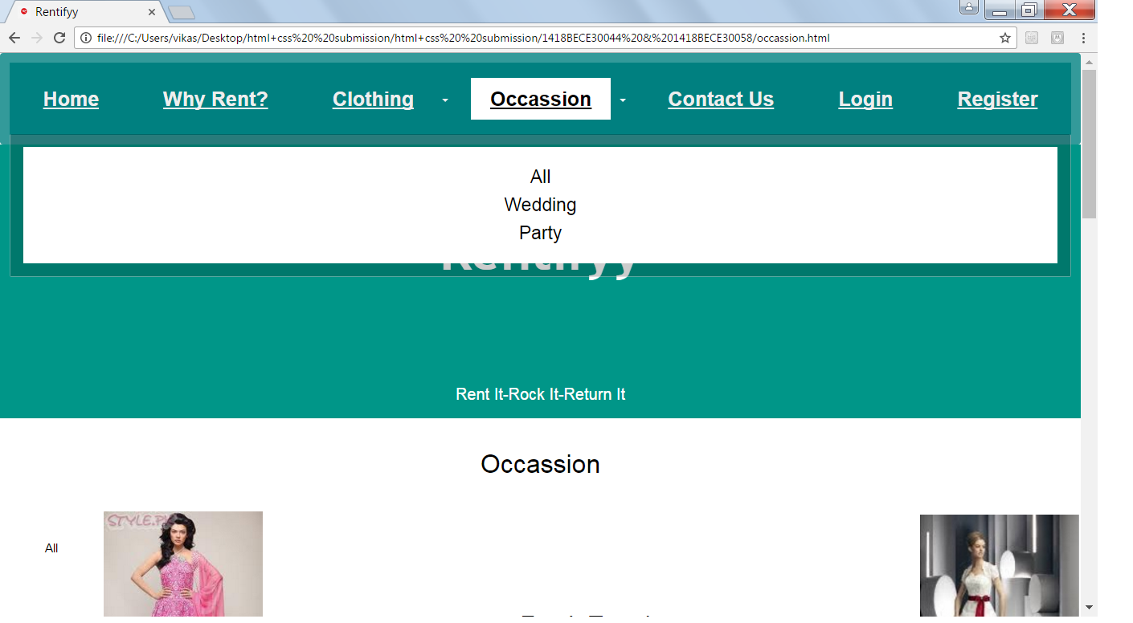

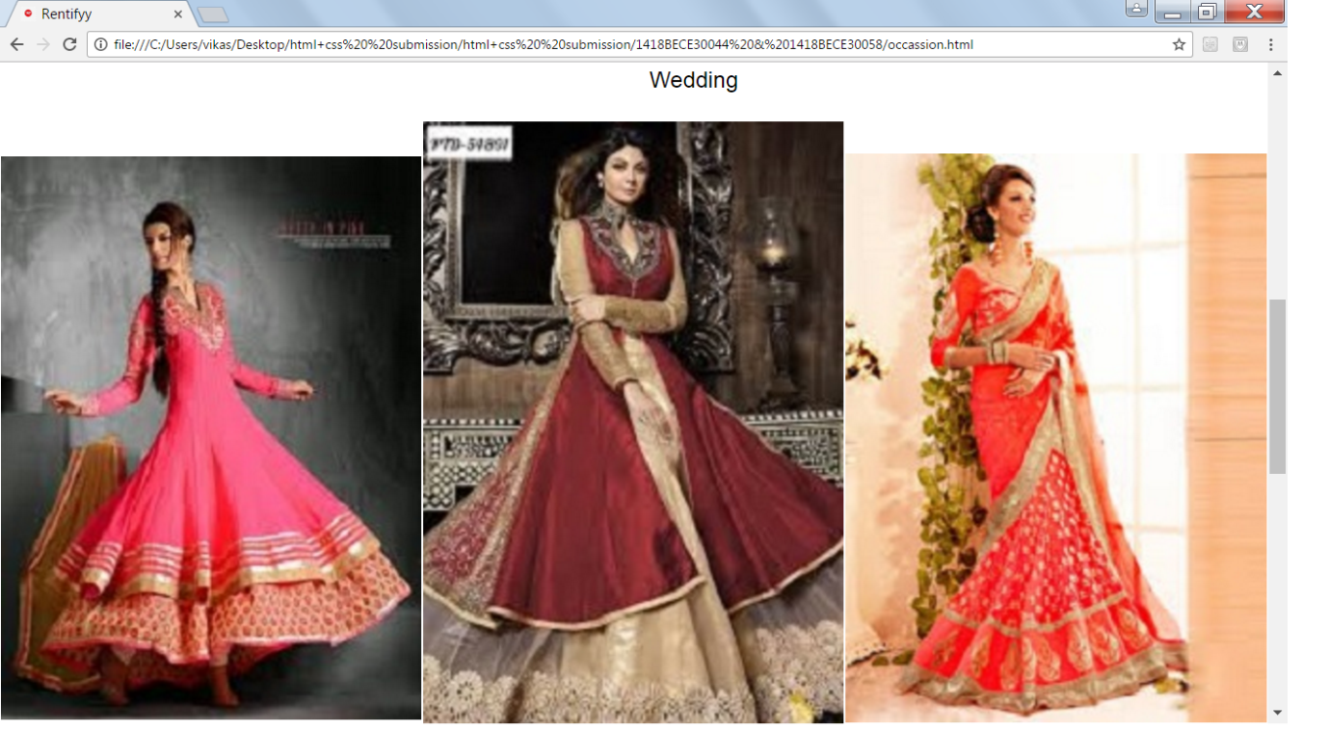

This category of Occasion gives user the option of selecting clothes for Wedding and Party.

Module-Contact Us

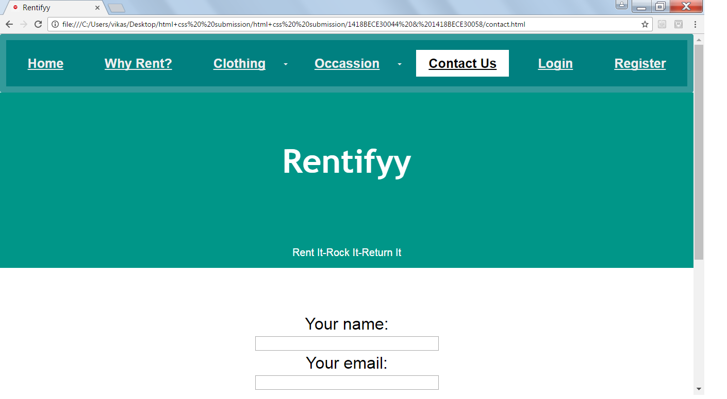

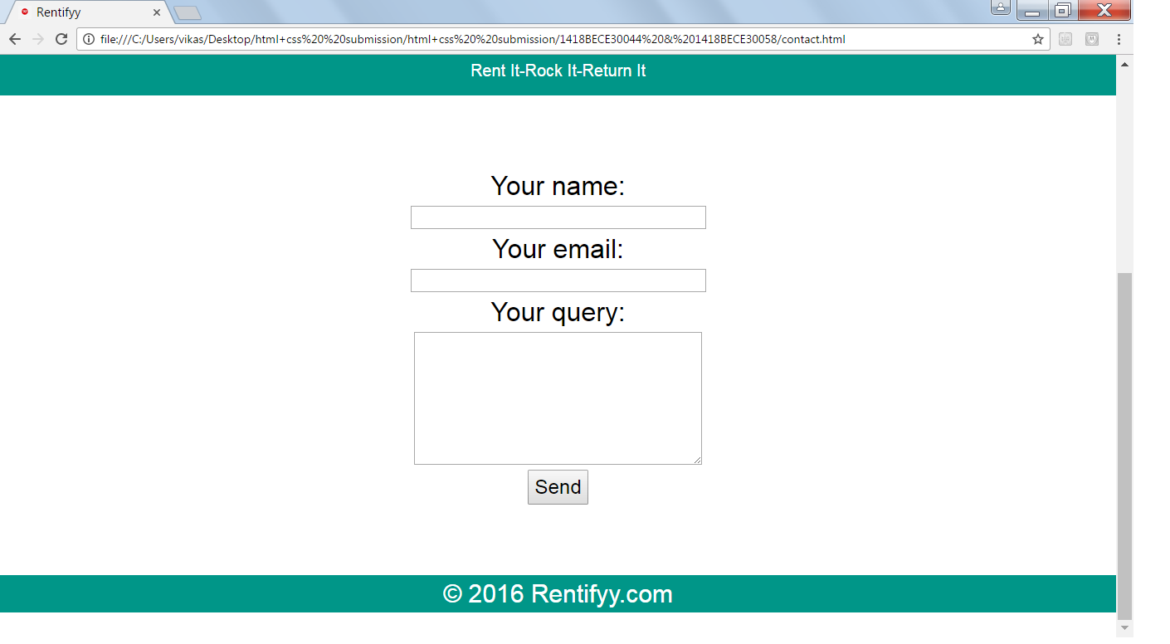

Users can contact us and send us their queries through “Contact Us” page.

Database-1418BECE30044&30058

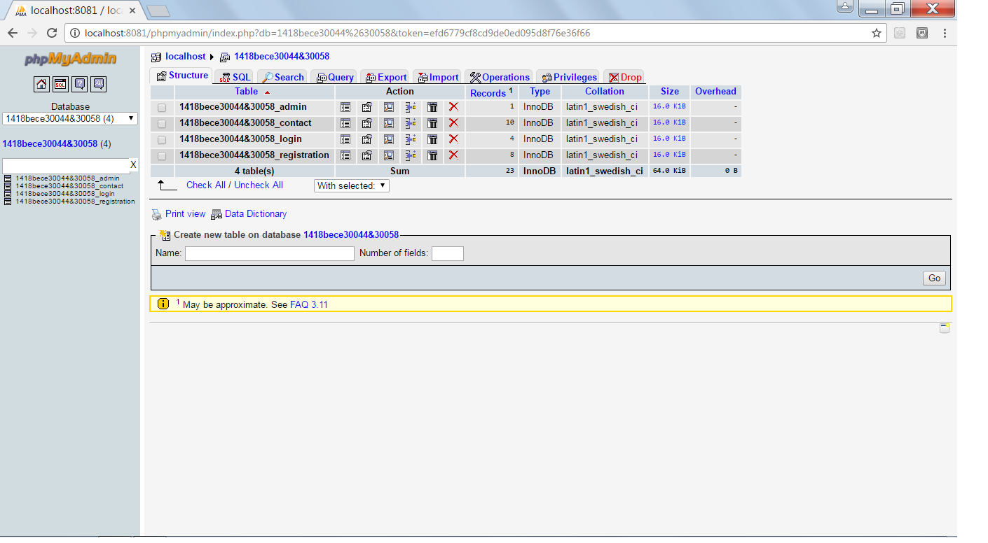

In this database we have 4 tables; in which we’ll look for 1418BECE30044&30058_contact table in which contact_us forms entries are saved.

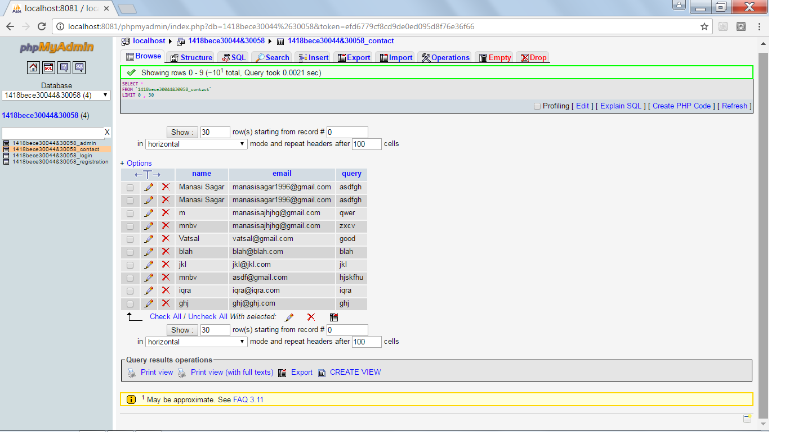

Module-Login

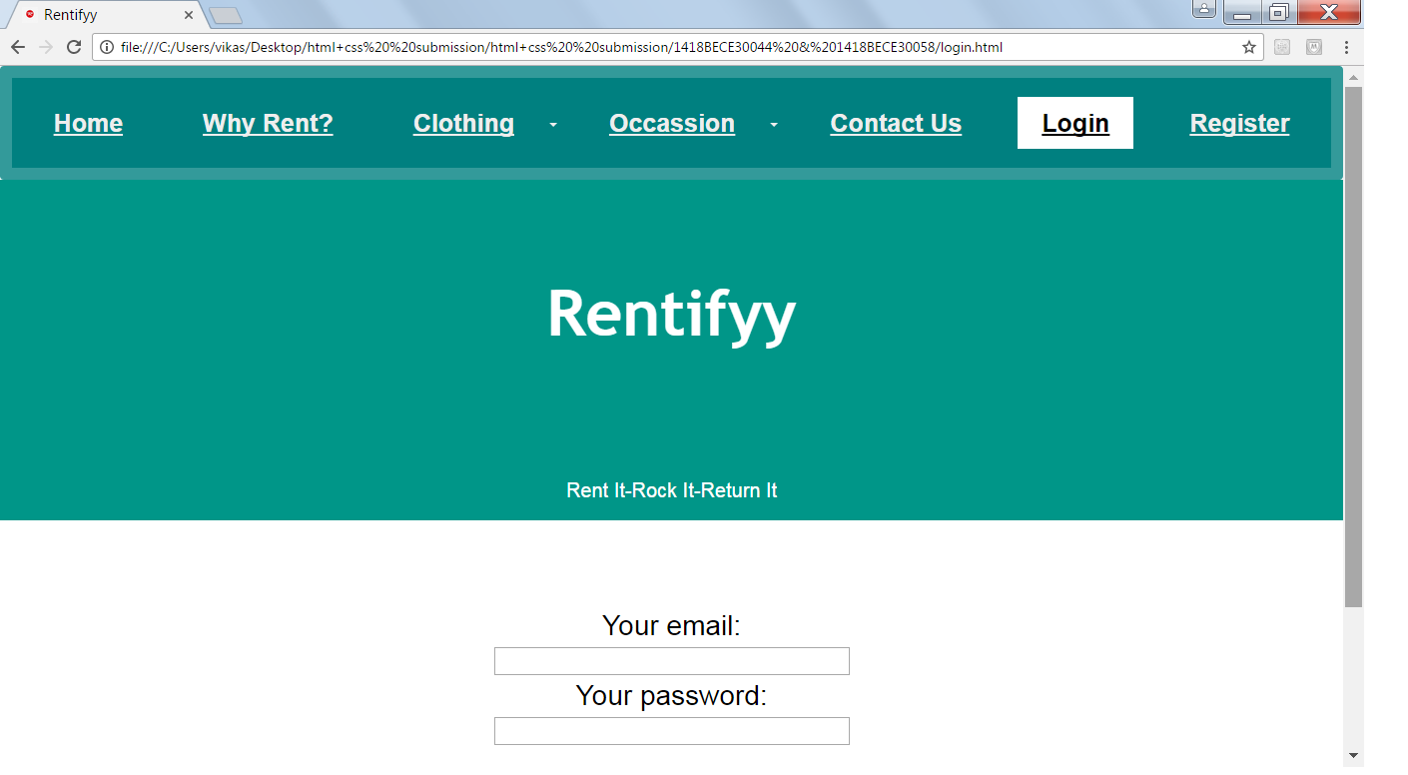

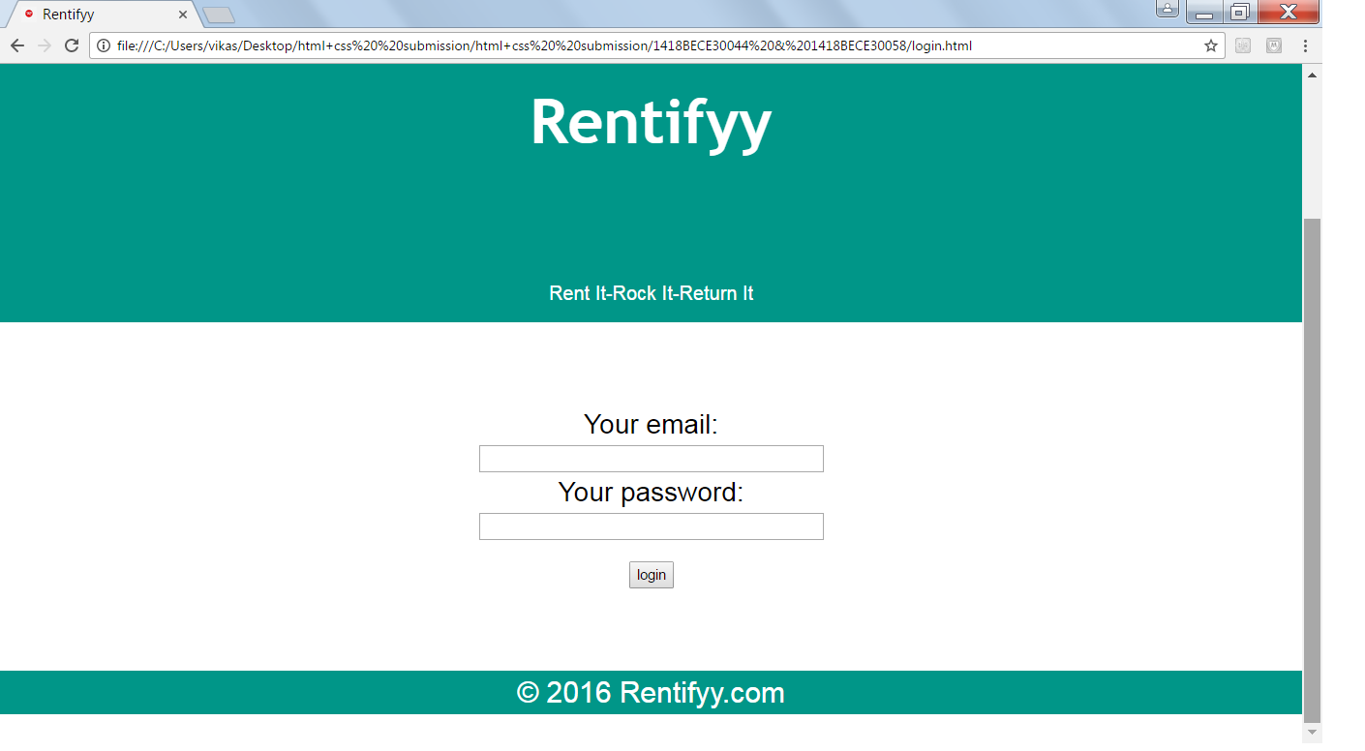

Registered users can login through this page to have access to their accounts.

Table-1418BECE30044&30058_login

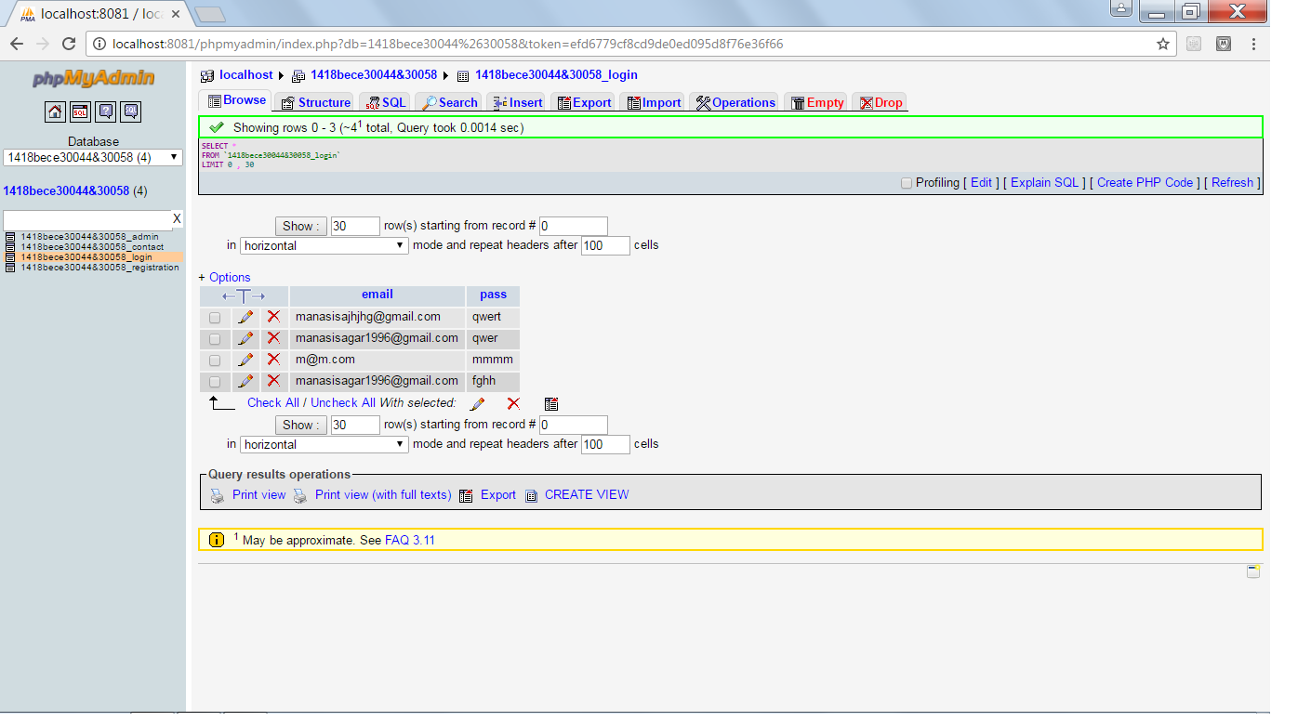

As shown above, the entries in login form will be stored in

1418BECE30044&30058_login table.

Module-Register

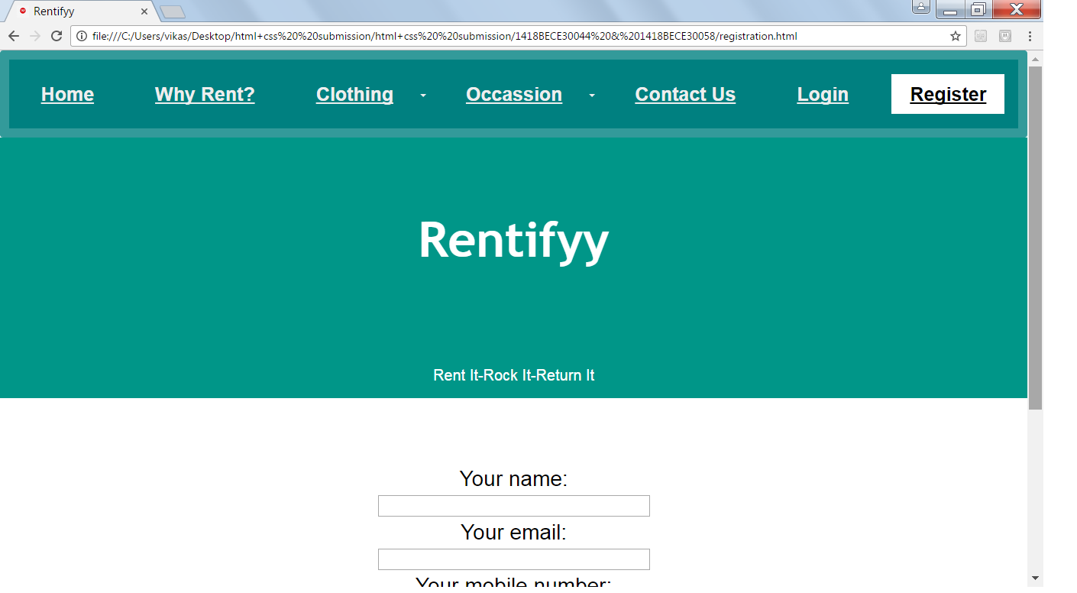

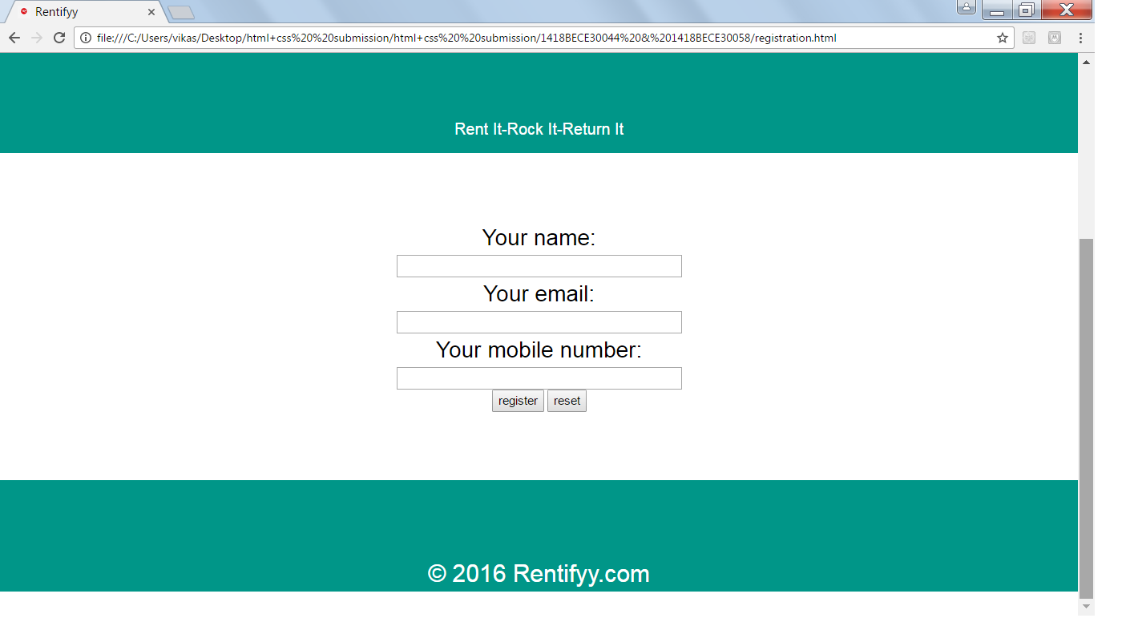

First time users can register themselves through this

Registration page by filling required details.

Table-1418BECE30044&30058_registration

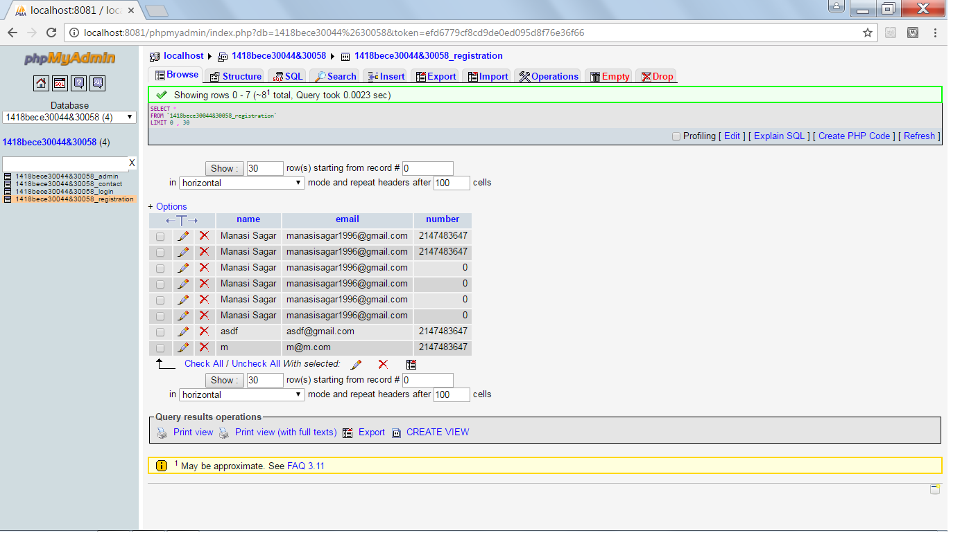

As shown above, the entries in registration form will be stored in 1418BECE30044&30058_registration table.

Module-Admin

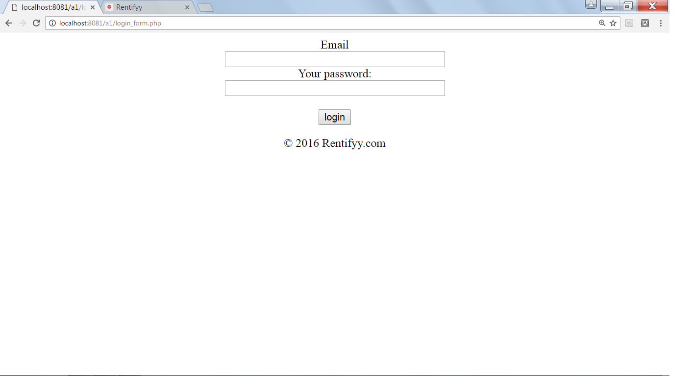

This the login page for admin. By logging in, admin can access modules page in which he can see modules as well as their entries.

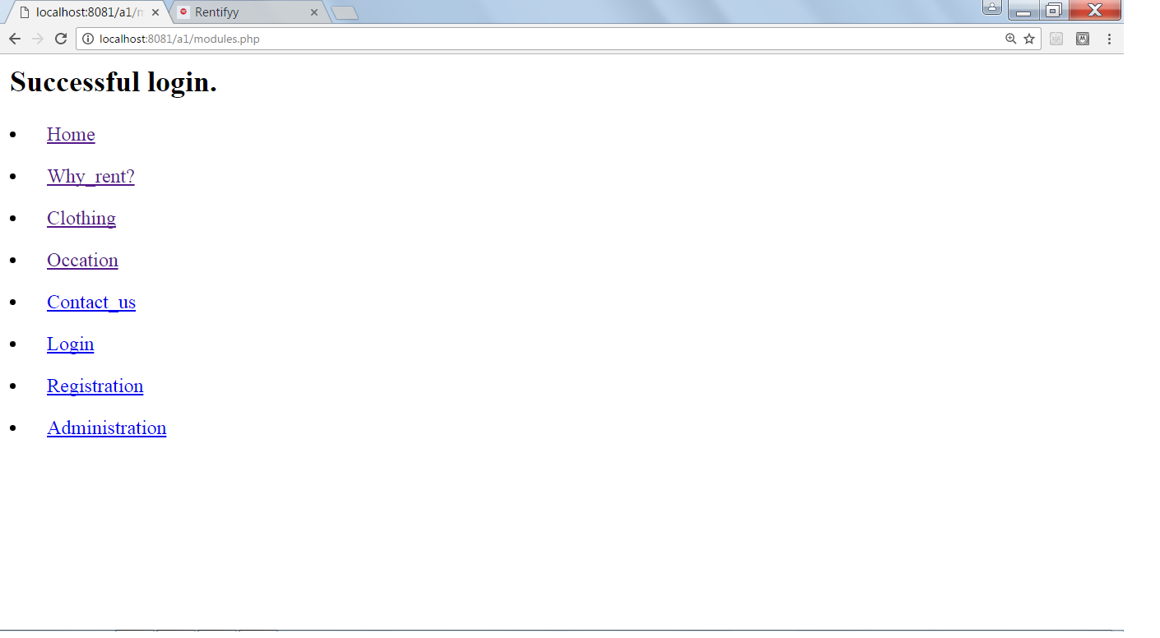

Table-1418BECE30044&30058_admin

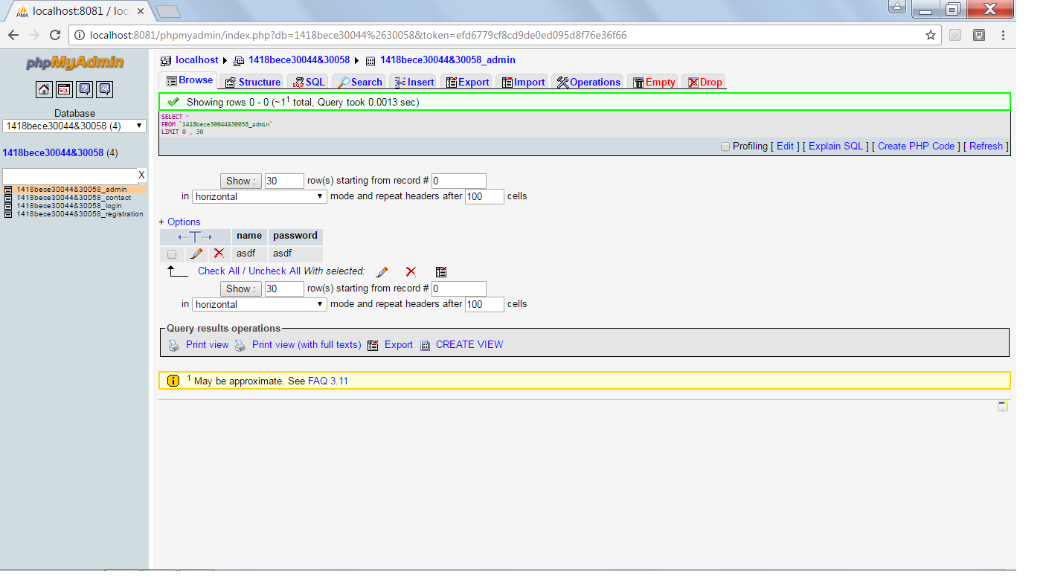

As shown above, only one static entry is already stored in admin table & when admin will access the admin login form, it will compare it with the static value stored in the admin table named as 1418BECE30044&30058_admin.